

Documentation of the OOP project
School of Information Systems and Engineering
Discipline: Object-Oriented Programming
Project Name: University System

Team members:
Torekhan Zhaksylyk
Kenzhiyeva Nazerke
Zholdasbekova Aidana
Serik Ersultan

Professor:
Zhumadir Nadira

CONTENT OF DOCUMENTATION:
- Introduction
- Class and UseCase Diagrams
- Code
- Communication and Work Process
- Conclution

INTRODUCTION
Our project focuses on developing a console-based University Management System using Java. The system is designed to streamline various tasks within a university by providing distinct functionalities for different user roles. These roles include students, teachers, and administrators, each with their own specific access and operations. For example, students can view their grades, teachers can access the courses they teach, and administrators can manage user information.
We began by creating detailed diagrams to plan the system structure and workflows, ensuring a clear understanding of the relationships between different components. Next, we implemented the functionality using Java classes and methods, carefully organizing the code to ensure clarity and efficiency. Finally, we tested the system rigorously to identify and fix any issues.
The goal of this system is to provide an organized, secure, and reliable way to handle university operations, ensuring data integrity and accessibility for all users. Our report outlines the objectives, the design and development process, and the challenges we faced along the way. It also highlights potential future improvements that could make the system even more effective. This project allowed us to apply the programming skills and concepts we learned throughout the semester to solve real-world problems. By creating a system that simplifies university operations, we’ve built a foundation for further enhancements and a deeper understanding of software development.

Class and UseCase Diagrams

UML diagrams play a pivotal role in helping us visualize system structures and gain quicker orientation during the coding process. They provide a clear blueprint for understanding the relationships between components, reducing ambiguity and fostering efficient collaboration among team members. By leveraging UML diagrams, we can streamline development workflows and ensure the alignment of implementation with design objectives.

Use Case Diagrams: Use case diagrams visually represent the interactions between users (actors) and the system. They illustrate the functionalities the system provides, focusing on user goals and how the system supports those goals.
Class Diagrams: Class diagrams provide a detailed view of the system's structure, showcasing its classes, attributes, methods, and relationships such as inheritance, associations, and dependencies. They are essential for modeling object-oriented systems

CODE

To not mess in codes we devided all classes, enums etc. to packages
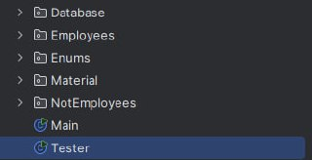
Components of Packages:

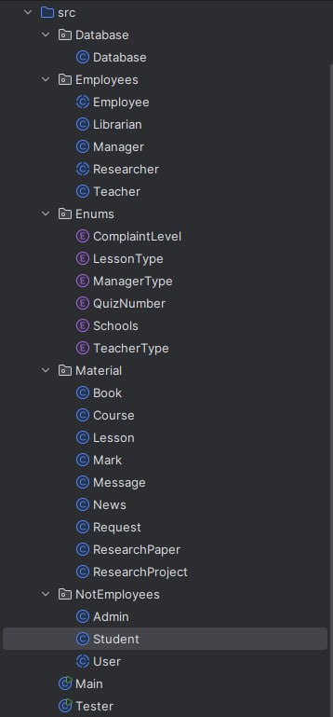


OUR DATABASE:

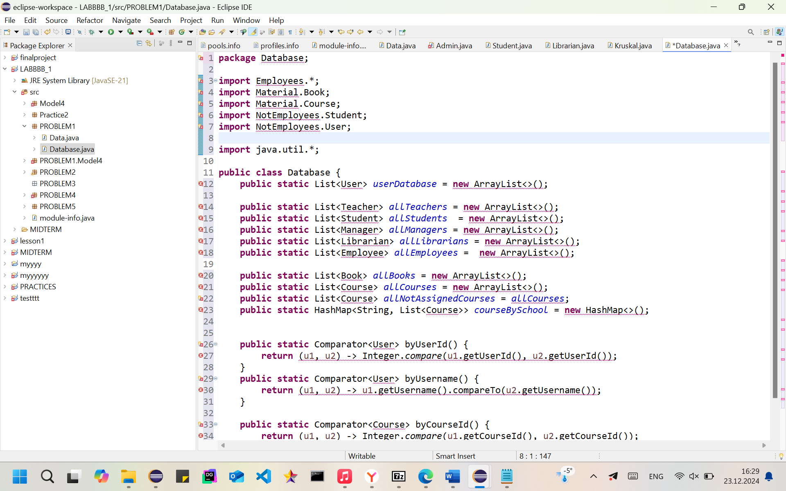

MAIN CODES: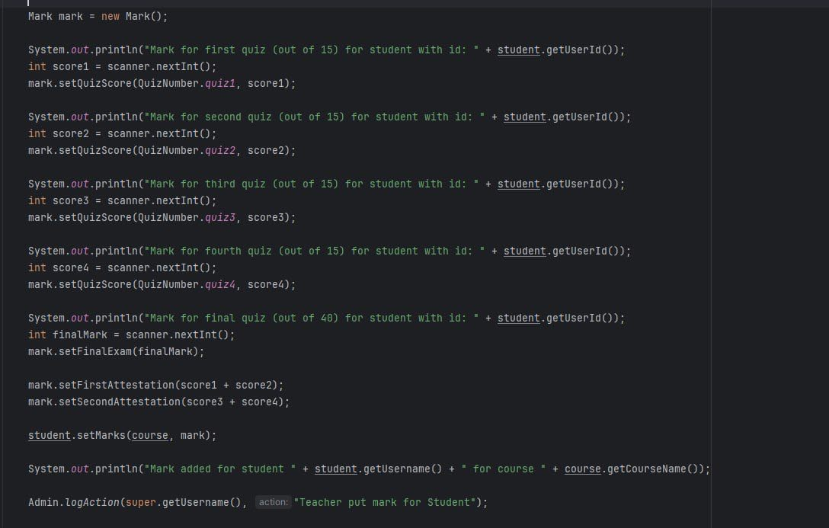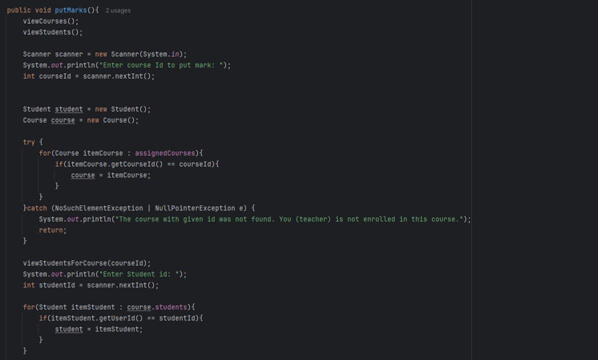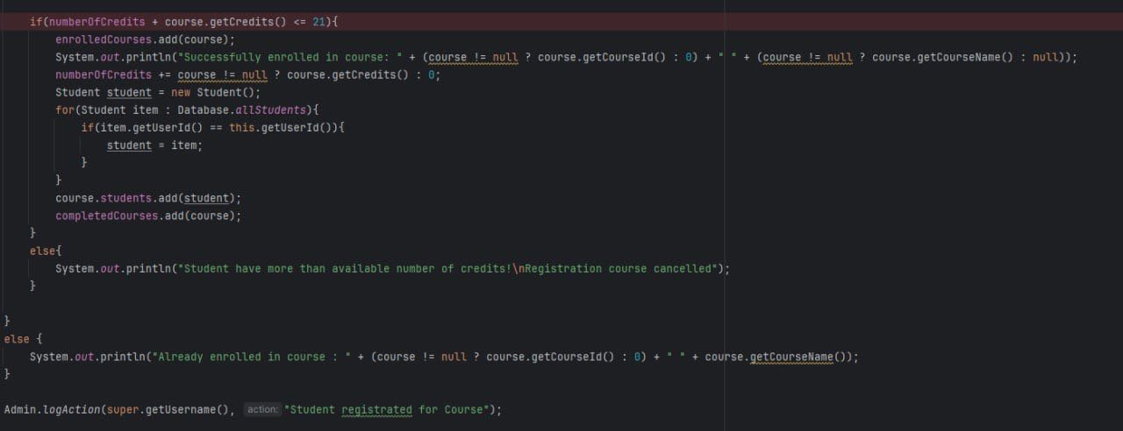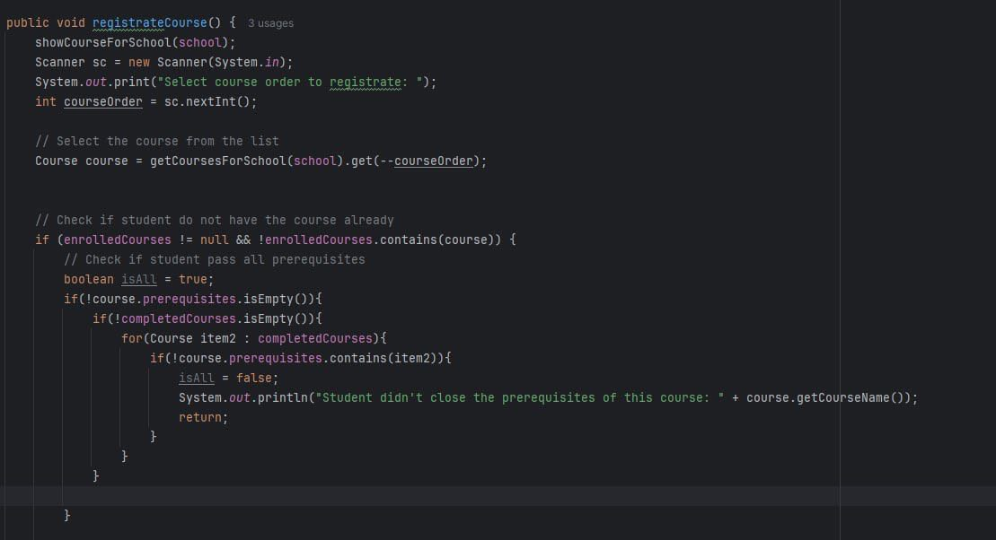

Communication and Work Process

Our group created a Telegram group where we consulted with each other. Additionally, we had a Teams group where we held calls. We also had in-person meetings where we discussed problems and preparations face-to-face. There were moments when we hit roadblocks, such as working on the interface in three languages.

Programs we used :

- Unfortunately, our team did not use programs designed for collaborative remote work to create code and diagrams. Instead, each member used the software they found most convenient for writing code individually.
- For creating diagrams, we all used StarUML.
- 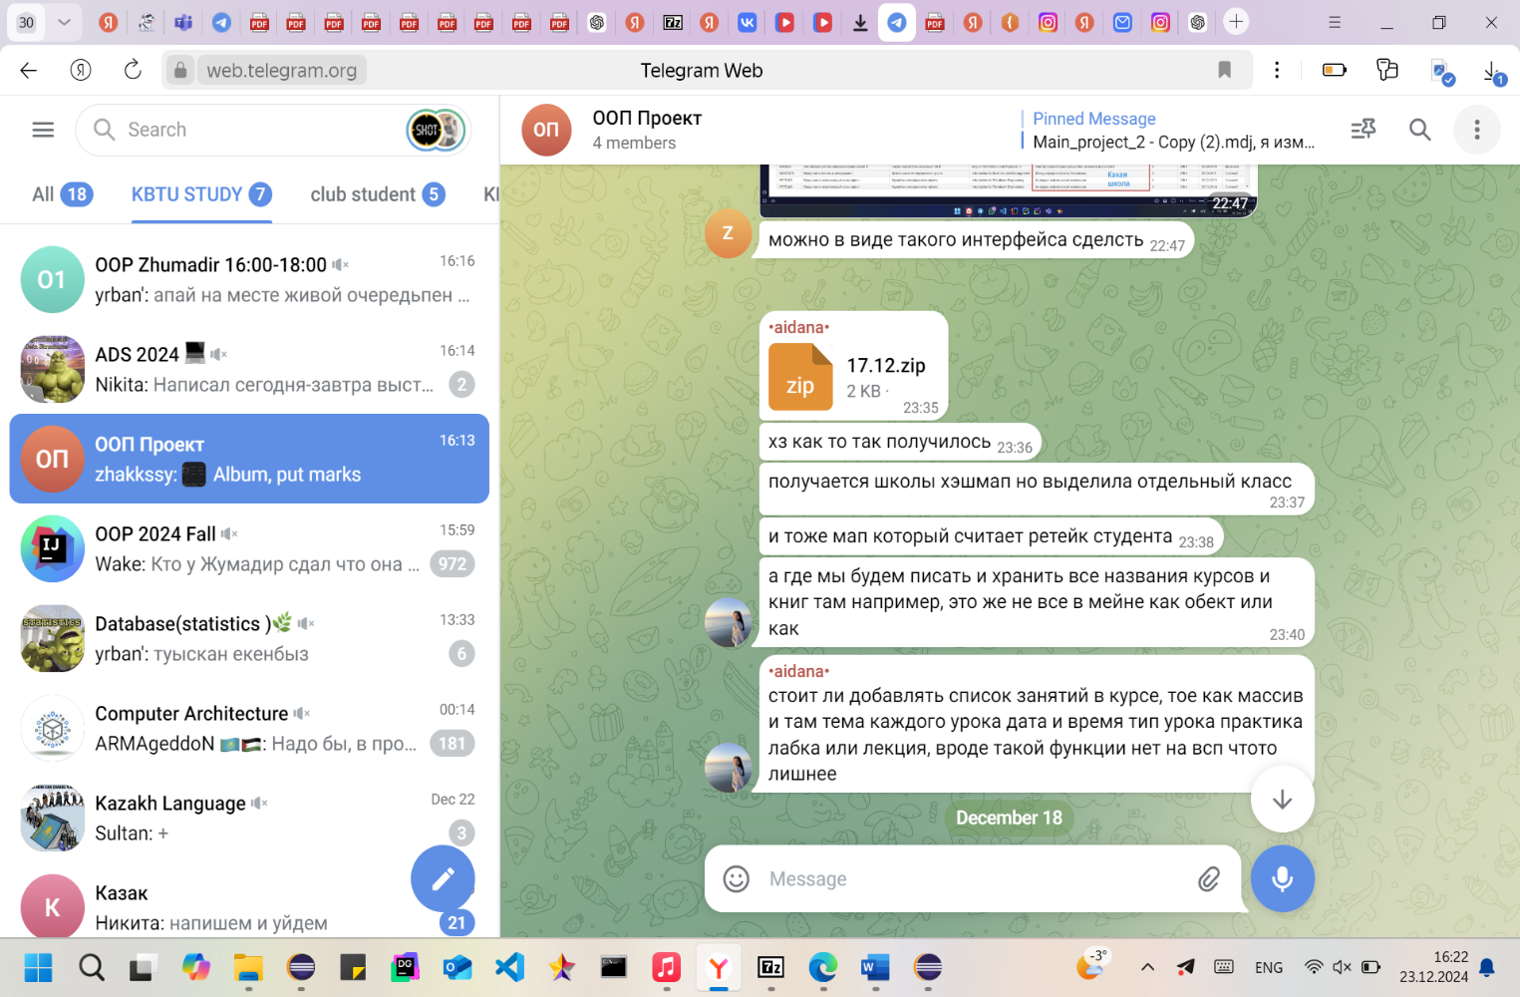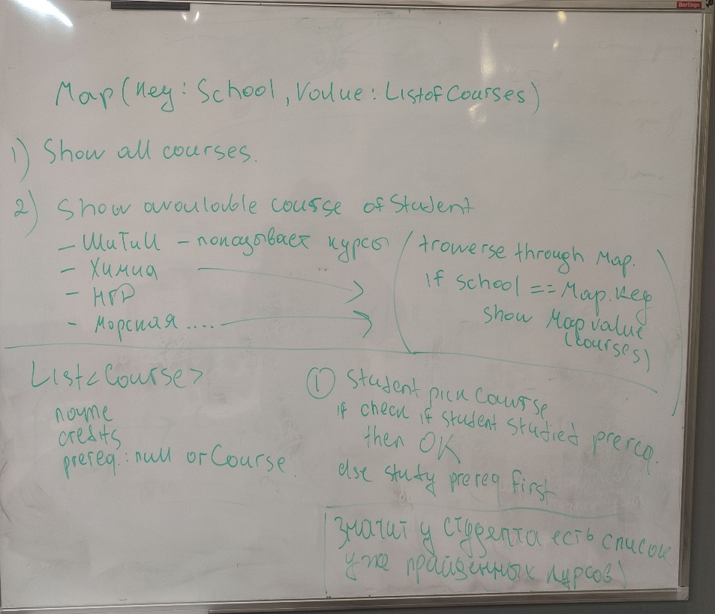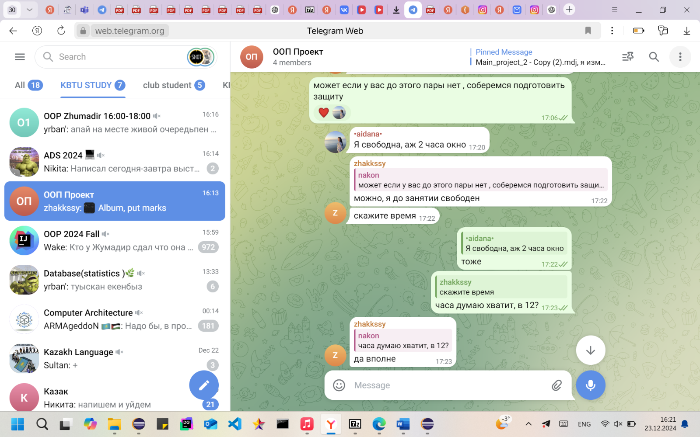

CONCLUSION

For our team, this project became an essential learning experience, helping us enhance both our technical expertise and teamwork capabilities. It offered valuable lessons in efficient collaboration, task management, and effective communication. By dividing responsibilities strategically and leveraging each member’s strengths, we were able to achieve the project’s objectives successfully.
Throughout the project, we applied numerous programming concepts, including comparators, exception handling, serialization, and inheritance, which formed the backbone of our system’s functionality. These concepts allowed us to bridge theoretical knowledge with practical implementation, providing clarity and resolving uncertainties throughout the process.
While the project partially fulfilled our initial goals, it greatly contributed to our understanding of key programming techniques. We refined our skills in sorting data with comparators, ensuring reliable error handling through exceptions, implementing serialization for efficient data storage, and using inheritance to create a structured and maintainable system. These achievements reflected the practical application of our classroom knowledge and aligned closely with the project’s core objectives.
Beyond the technical aspects, the project emphasized the importance of collaborative problem-solving and teamwork. By effectively coordinating our efforts and supporting one another, we not only met but exceeded our expectations. This experience demonstrated how essential strong team dynamics and mutual cooperation are for the successful completion of any project.

